prepAIred: Intelligent Platform for Interview Preparation and Simulation

Abstract
Interview preparation is one of the most challenging aspects whenever a person is extensively searching for a job. It can vary from confusing to outright difficult, based on one's experience. With the advent of Large Language Models (LLMs), the preparation process can be reimagined, therefore fixing the generic interview training’s biggest weakness - failing to target the candidate’s strengths, flaws and career aspirations [1].
This article introduces prepAIred, an intelligent platform that leverages LLMs to deliver personalized interview preparation, tailored to each candidate’s unique needs [1][2]. Instead of offering a universal guide, prepAIred uses an adaptive learning experience through dynamic interactions with its candidate. AI models are used to enable users to practice their own version of an interview scenario with topics, questions and feedback all based on the candidate’s skill, background and career aspirations.
By analyzing the candidate's requests, responses and learning patterns, the platform strategically adapts its internal coaching strategies, targeting the user’s gaps, strengths and thereby enabling a more effective interview preparation experience. User evaluations demonstrate successful performance adaptation across different experience levels, validating the platform's personalization capabilities.
This work contributes to the emerging intersection of educational technology and generative AI, demonstrating how large language models can provide scalable, personalized professional development tools.

Keywords: Personalized Interview Preparation, Large Language Models, Adaptive Learning, Interview Simulation

Introduction
Technical competency and adapting to dynamic environments are essential skills required by candidates nowadays in order to successfully secure the job position they are applying for. With the rise in demand for qualified professionals, more candidates are looking for ways to improve their knowledge and expertise.
Technological advancements and access to artificial intelligence opens new opportunities for personalized and automated approaches in this area. In this context, the web-based prepAIred platform is developed as a contemporary solution that integrates an intuitive user interface with powerful analytical tools and AI functionalities, aimed at enabling candidates to prepare more effectively for their interviews.
The platform integrates multiple LLMs to coordinate an entire interview pipeline - from generative question generation to real-time response evaluation [10]. Voice interactions are facilitated through a conversational agent, enabling candidates to simulate authentic interview conditions through natural language dialogue [6][7].
To validate the platform's effectiveness, two user evaluations were conducted, both having different experience levels. Results demonstrated various performance adaptation, indicating successful personalization of interview difficulty and question relevance. Their feedback identified areas for enhancement of the application, establishing a roadmap for future iterations.

Purpose
The main objective of prepAIred is to help users better themselves in the interview preparation process, by combining modern interview best practices with the assistance of artificial intelligence. At the heart of the application is the desire to aid users with understanding and real-life examples of an interview process, as well as to achieve their best results in it.
The application is aimed at a wide range of audience - from university students looking for an internship to companies looking to modernize and ease their hiring process. For this reason, prepAIred is designed with remarkable care for the user experience - the offered interface is designed with accessibility first improvements in mind, as well as to be easy to use by all kinds of users, both on Desktop and Mobile devices.
The primary purpose of the development is to be an AI-first platform, with seamless integration with Large Language Models that are in control of the entire Interview process -from generating the questions, evaluating the given answers and giving meaningful feedback to the user [1][5]. This implementation aims not only at the automation of repetitive coaching tasks, but at creating an intelligent system that adapts to the user requirements, responses, identifying skill gaps, and adjusting its coaching strategies in real-time, to be intact with those of the user [4].
By utilizing several LLMs, the platform leverages the strength of each model to deliver comprehensive interview preparation that evolves with the candidate’s learning trajectory.

Analysis of Application Requirements
The design is based on functional and non-functional requirements - efficiency, security and convenience for the end user. Among the basic functionalities are:
- User authentication
- User-friendly interface (UI/UX)
- Integration with LLMs that power all the AI-related functionalities
The platform features a responsive, user-centric interface accessible across mobile and desktop environments, requiring no technical expertise to navigate. The layout structure is divided into four separate pages, each of which is responsible for the different functionalities – home page with user-related information, interview creation/evaluation, AI-enabled mock interviews [2] and user statistics.
In terms of non-functional requirements, the project relies on a high level of security through the use of password hashing and access control. Productivity is a priority, as the system must work quickly and reliably even at higher loads. The code architecture is structured and well documented, which facilitates future updates and extensions.

Integration with Large Language Models (LLMs)
To implement the main functionality of the application, generating and conducting personalized interviews, integration with external services based on Large Language Models (LLM) has been implemented.
The system is designed as a platform in which Artificial Intelligence is a leading element, using different services depending on the user's choice. Supported agents include:
- Claude Sonet 4
- GPT-4o
- Gemini Flash 2.0
The integration is implemented through an abstract layer (AIService) that allows flexible replacement and extensibility of the used LLM models without changing the business logic of the application.
On Fig.1 the process of generating interview sessions by LLMs is shown.

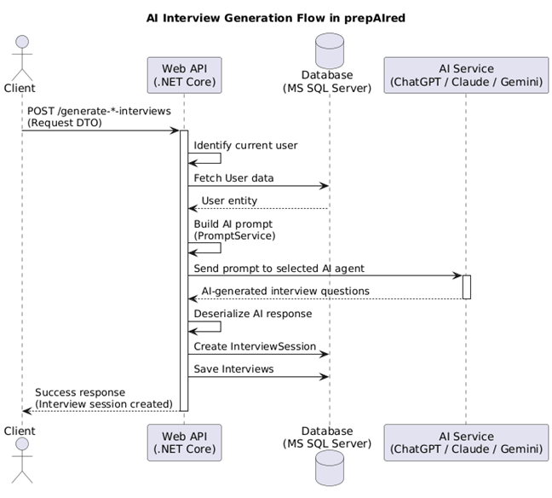

Fig. 1. Process of generating interview sessions

Functionalities
The application offers several functionalities that are responsible for testing the user’s interview skills:
- Interview Sessions
- Mock Interviews
- Performance Statistics
The Interview Sessions [3] allow users to design custom interview scenarios by specifying the job role, position seniority and key topics they wish to focus on. The platform generates a series of tailored questions based on these parameters, and users answer directly through the interface [10]. Responses are recorded and stored for later analysis, enabling users to track their answers and review their performance.
The Mock Interview [4] puts the user into a real-time dynamic conversational experience. Built with Users engage in dialogue with an AI agent that is trained to act as an interviewer, asking questions and responding naturally to candidate questions and answers [6][7]. This interactive format aims to simulate authentic interview conditions, allowing users to practice not only answering questions, but thinking and managing the flow of an actual conversation [3][5].
On Fig.2 the process of simulating interview with an AI voice agent is shown.
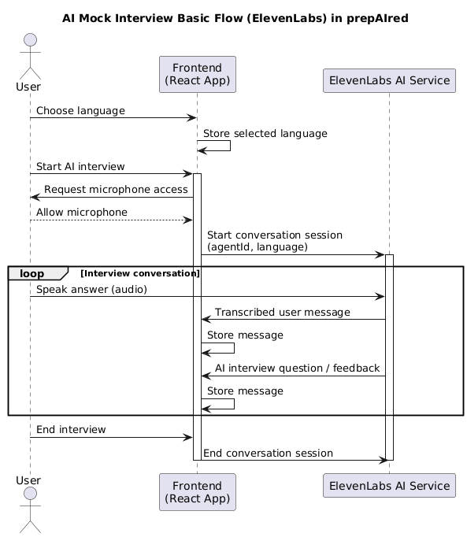

Fig. 2. Process of simulating interview with an AI voice agent

Statistics provide insights into the Interviews the user has taken. It displays performance metrics, interview scores, strengths and weaknesses, and tracks improvement over time. Users can review past data, compare scores across different interview types, giving them a good example whether they are ready for an actual interview.

System Implementation
The prepAIred platform was developed as a web-based application utilizing .NET Core for server-side operations and React for the user interface. The system leverages several generative AI services from OpenAI, Anthropic, and Google Gemini. They are used to dynamically generate role-specific interview questions and simulate real evaluation of candidate responses [1][2][10].
AI models process information provided by the user to produce technical and HR questions tailored to each interview scenario. The interactive voice functionality is enabled by conversational agents, developed by ElevenLabs, which allows a natural two-way voice interaction by managing conversation flow [6][8].

Results
Two tests were conducted with the application - one on a student currently studying a major in Computer Science, and another on a software engineer with three years of professional experience.
The student quickly examined the application and its main components – the AI generated interviews and mock interview. They were able to generate and complete 5 interview sessions, each containing ten questions. The results varied depending on the topics and difficulty of the questions, but finally a result of 5.7 points out of 10 was achieved.
The student then proceeded to try out the mock interview, where they spent a large amount of time, as one mock interview session lasts roughly 40 minutes. In the end, they managed to successfully complete both the interview sessions and mock interviews and gave significant good feedback, as well as suggesting some quality-of-life changes to make the application better.
When examining the system, the software engineer took their time to look at as many details as possible - user interface, requests, responses, performance under specific traffic conditions, security, scalability, semantics of the HTML, WAI-ARIA support, ADA compliance, different LLM performance and many others. Their interview sessions were a lot better compared to the student – resulting in an average score of 9.2 points out of 10 across 5 interview sessions.
As for the mock interview, they were able to finish an interview for a position of junior engineer within 25 minutes, leaving the AI agent suggesting them try and apply for a higher position, based on the knowledge the software engineer possesses. Once they were done with both functionalities, they gave me extensive feedback on what they liked, disliked and thought should be changed for the application, including:
- WAI-ARIA – while prepAIred incorporates basic ARIA labeling and role definitions, coverage remains incomplete, as users who rely on screen readers may encounter gaps in landmark navigation, live region announcements, and semantic relationships between form elements and their descriptions.
- WCAG – the currently implemented accessibility covers only level A, which is the minimum, foundational level for WCAG, level AA is desirable for future updates, as this is the essential standard for accessibility and represents the industry’s best practices.
- Security – the current security includes CORS, HTTPOnly cookies, JWT authentication and password hashing, however, additional checks were recommended, that include rate limiting, Content Security Policy (CSP) headers to prevent cross-site scripting (XSS) attacks and encryption of sensitive data.
Based on the above results and feedback from the two users, it is evident prepAIred demonstrates a strong foundation for an application dedicated to AI-powered interview preparation, several refinements are necessary to elevate the application to a production-ready standard. Addressing accessibility gaps, as well as enhancing security are the two critical priorities for future development cycles.

Conclusion
The proposed application demonstrates how LLMs can be integrated in the interview preparation process and help the user better prepare for their upcoming interviews, by simulating real-life interview scenarios [1][2][3].
The program offers a modern interface with an AI-powered internal system for helping the user improve their skills by simulating real interview scenarios [4][5]. The internal architecture allows for easy updating with new features and implementations, and it is built with future improvements in mind [9].

References
[1] K. D. Bhavani, G. H. S. V. K. Prasad, V. G. S. S. Krishna, M. S. K. Reddy, K. S. Vardhan, and Md. Sadik, "Prep AI - Customized Mock Interview Platform Using Gen AI," International Journal of Innovative Science and Research Technology, pp. 1981–1981, Jan. 2026, doi: 10.38124/ijisrt/26jan835.
[2] P. Mishra, A. K. Arulappan, I.-H. Ra, T. M. L, G. R. G, and Y. Lee, "AI-Driven Virtual Mock Interview Development," in Proc. IEEE SCISISIS, pp. 1–4, Nov. 2024, doi: 10.1109/scisisis61014.2024.10760210.
[3] S. Uttekar, S. Gonjari, and I. Abuj, "AI Powered Platform for Interview Simulation Candidate Evaluation and Recruitment Workflow Optimization," Research Square, 2024. [Online]. Available: https://www.researchsquare.com/article/rs-7951657/latest
[4] R. Amina, "Building a Chatbot for Interview Preparation," University of Biskra, 2024. [Online]. Available: http://archives.univ-biskra.dz/bitstream/123456789/29156/1/RIHANI_Amina.pdf
[5] N. Yazdani, A. Mahajan, and A. Ansari, "Zara: An LLM-based Candidate Interview Feedback System," arXiv, 2025, doi: 10.48550/arxiv.2507.02869.
[6] H. Shankar and S. Nivetha, "VoxGuru: A Multimodal AI for Transformative Conversational Learning in Real-Time Dynamic Environments," in Proc. IEEE ICISC, 2025, doi: 10.1109/icisc65841.2025.11187982.
[7] Sangeetha M M, D. Gingupalli, N. Nelakurthi, C. Katta, and P. K. A. Setty, "AI-Powered Smart Learning Assistant with Speech Recognition," in Proc. IEEE ICACRS, 2025, doi: 10.1109/icacrs67045.2025.11324149.
[8] M. Nithya, S. Nandhini Devi, R. Shrivani, and D. Nivetha, "EmpowerED - Revolutionizing E-Learning for Diverse Abilities through AI/ML," in Proc. IEEE ICPECTS, 2024, doi: 10.1109/icpects62210.2024.10780230.
[9] T. Daryanto, X. Ding, L. T. Wilhelm, S. Stil, and K. M. Knutsen, "Conversate: Supporting Reflective Learning in Interview Practice Through Interactive Simulation and Dialogic Feedback," arXiv, 2024, doi: 10.48550/arxiv.2410.05570.
[10] M. Salıcı and E. Ölçer, "Impact of Transformer-Based Models in NLP: An In-Depth Study on BERT and GPT," in Proc. IEEE IDAP, 2024, doi: 10.1109/idap64064.2024.10710796.

